**Practical No:-7**

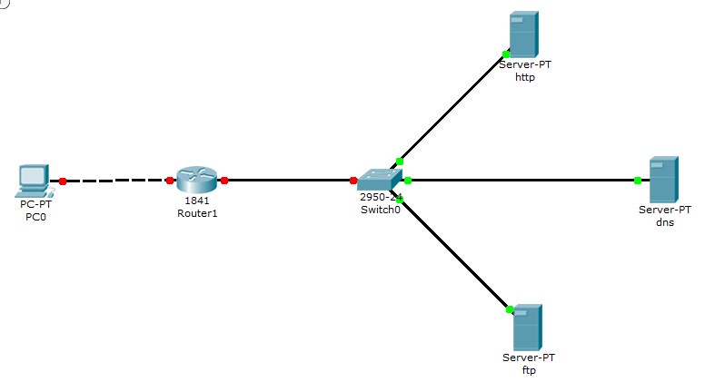

Step 1:-configuring PC0

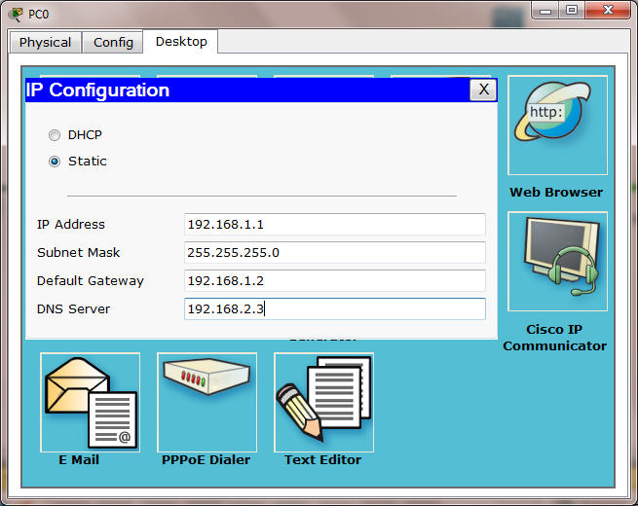

Step 2:-configuring HTTP

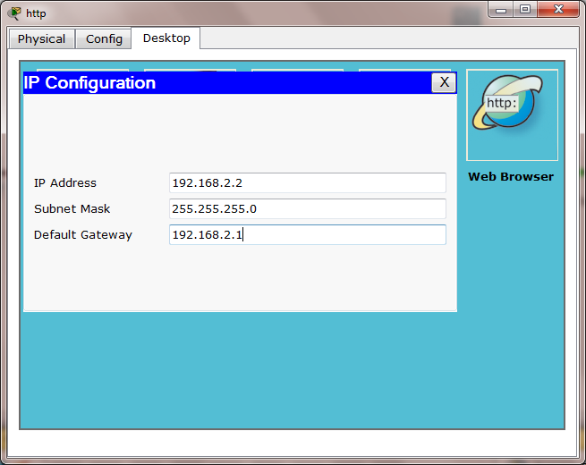

Step 3:-configuring DNS

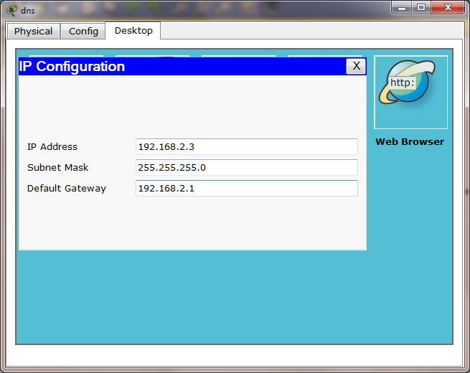

Step 4:-configuring FTP

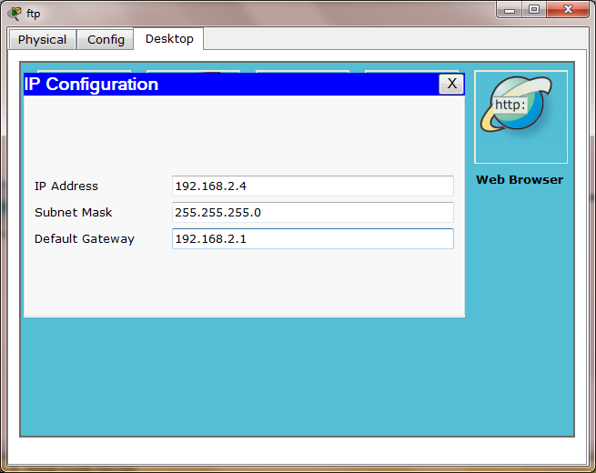

Step 5:-configuring Router0

Router>en

Router#config t

Enter configuration commands, one per line. End with CNTL/Z.

Router(config)#hostname r1

r1(config)#interface f0/0

r1(config-if)#ip address 192.168.1.2 255.255.255.0

r1(config-if)#no shut

%LINK-5-CHANGED: Interface FastEthernet0/0, changed state to up

%LINEPROTO-5-UPDOWN: Line protocol on Interface FastEthernet0/0, changed state to up

r1(config-if)#exit

r1(config)#interface f0/1

r1(config-if)#ip address 192.168.2.1 255.255.255.0

r1(config-if)#no shut

%LINK-5-CHANGED: Interface FastEthernet0/1, changed state to up

%LINEPROTO-5-UPDOWN: Line protocol on Interface FastEthernet0/1, changed state to up

r1(config-if)#exit

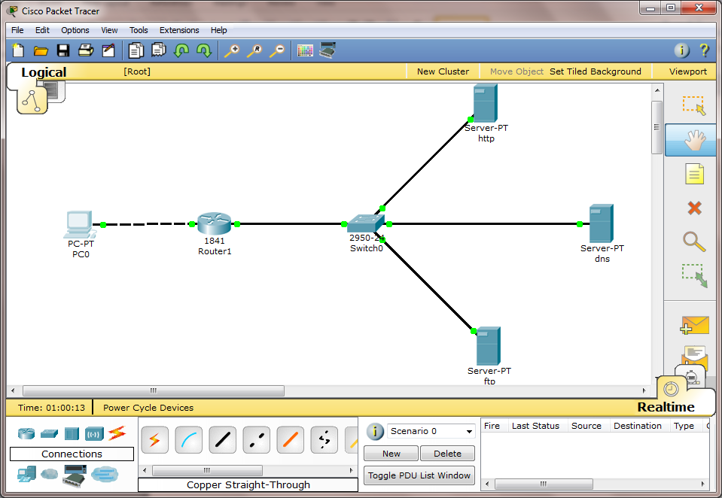

Step 6:-configuring HTTP -> Check if it is on

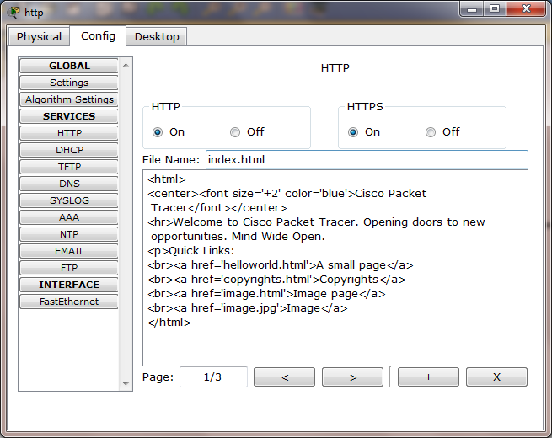

Step 7:-configuring DNS -> Check if HTTP is off

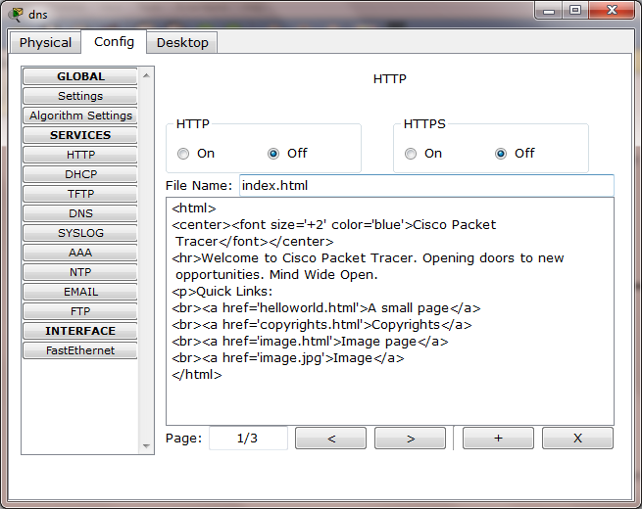

Step 8:-configuring DNS -> Check if DHCP is off

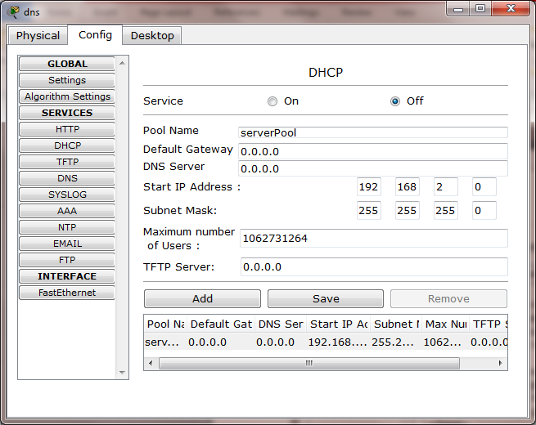

Step 9:-configuring DNS -> Check if DNS is On -> add name and address

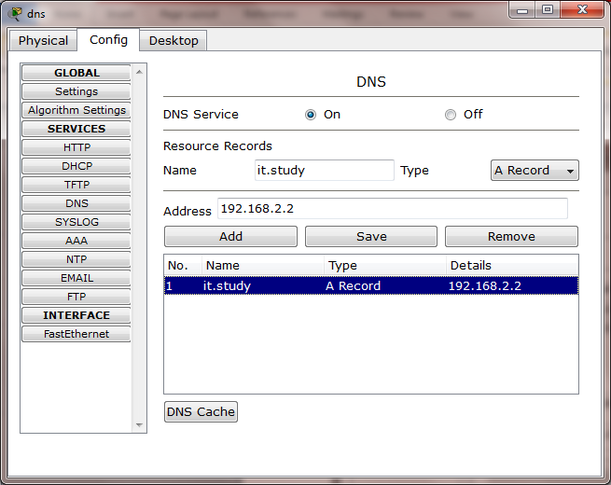

Step 10:-PC0 -> Desktop -> Web Browser -> Type url http://it.study

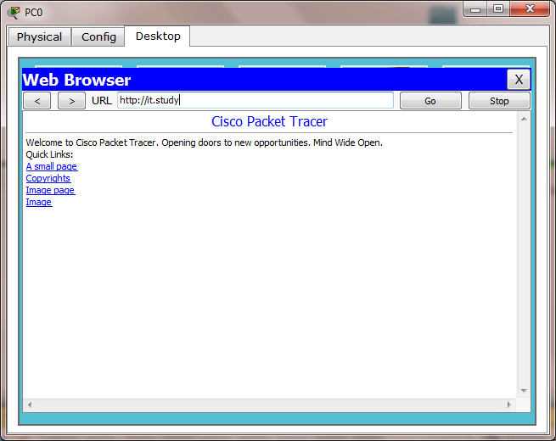

Step 11:-configuring PC0 -> Desktop -> Command Prompt -> Ping it.study

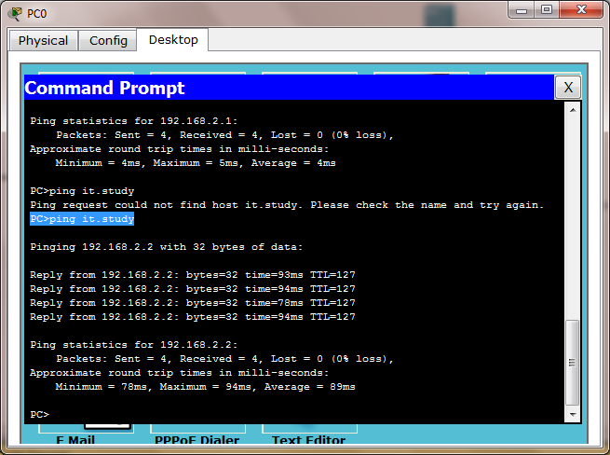

Step 12:-configuring FTP

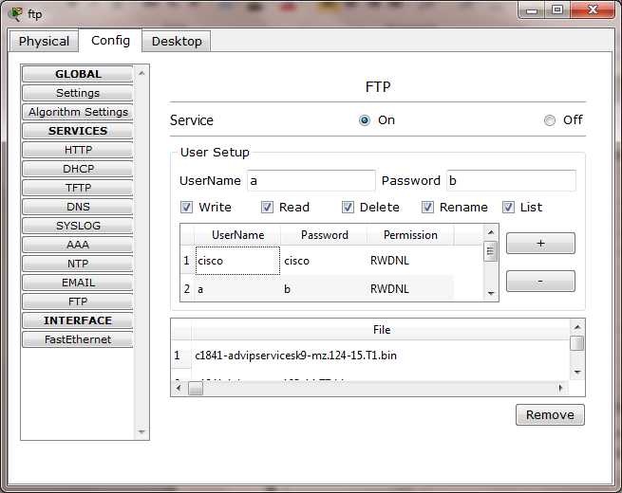

Step 13:-configuring HTTP in FTP -> Check if HTTP is off

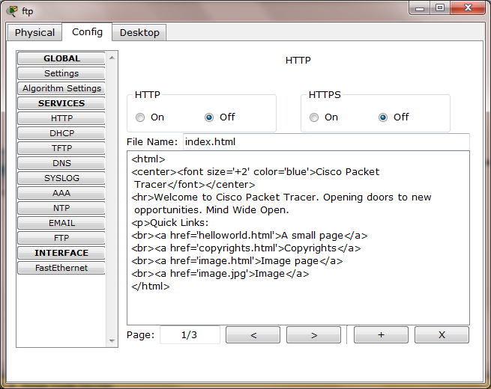

Step 14:-configuring DHCP in FTP -> Check if DHCP is off

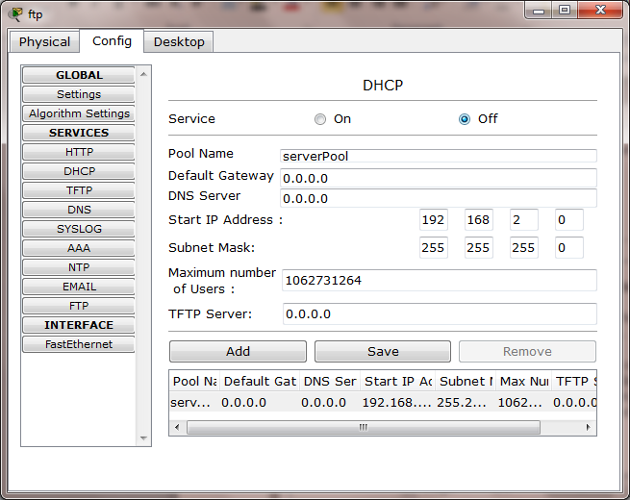

Step 15:-configuring DNS in FTP -> Check if DNS is off

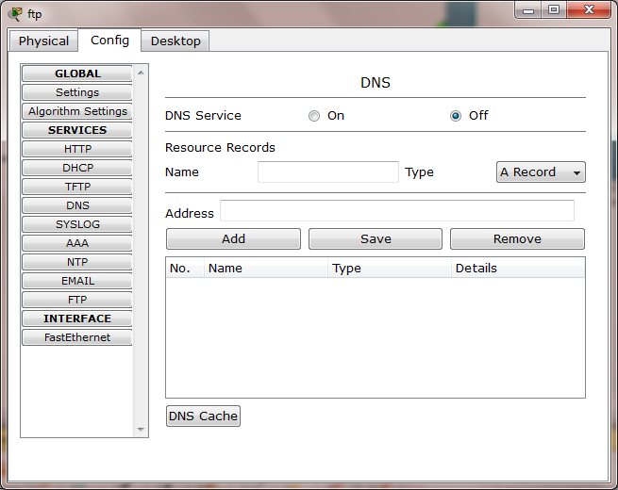

Step 16:-configuring PC0 -> Desktop -> Command Prompt -> ftp 192.168.2.4

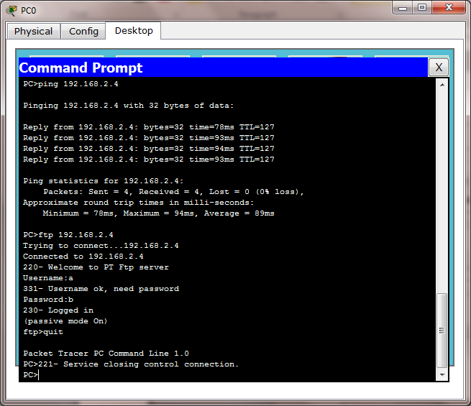

Step 17:- PC0 -> Desktop -> Text Editor-> Save it as a.txt

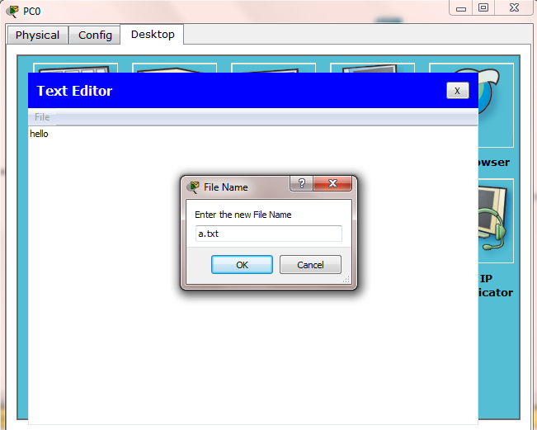

Step 18:-configuring PC0 -> Desktop -> Command Prompt -> put a.txt

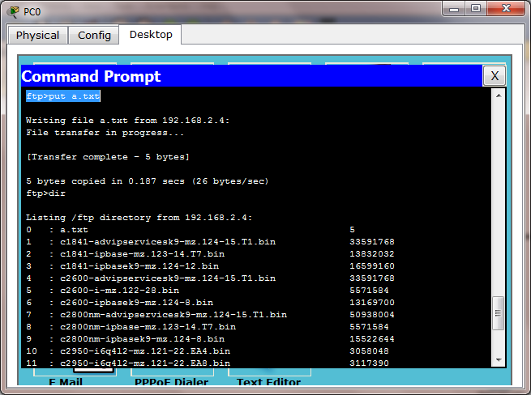

Step 19:-configuring PC0 -> Desktop -> Command Prompt -> dir

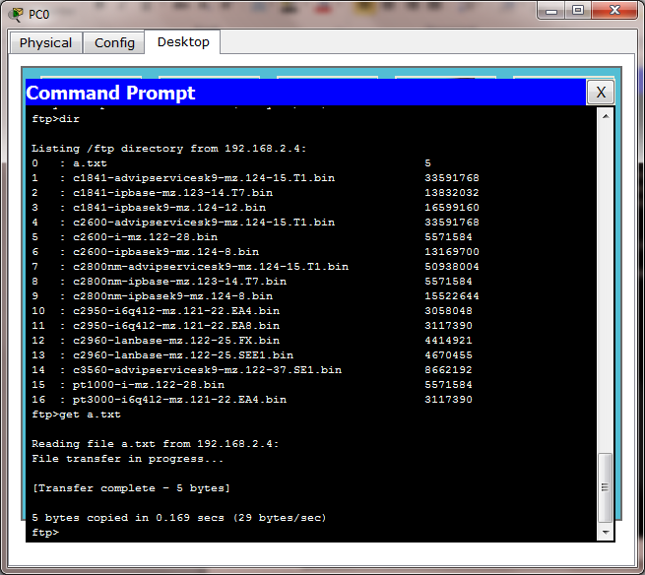

Step 20:-configuring PC0 -> Desktop -> Command Prompt -> get a.txt

